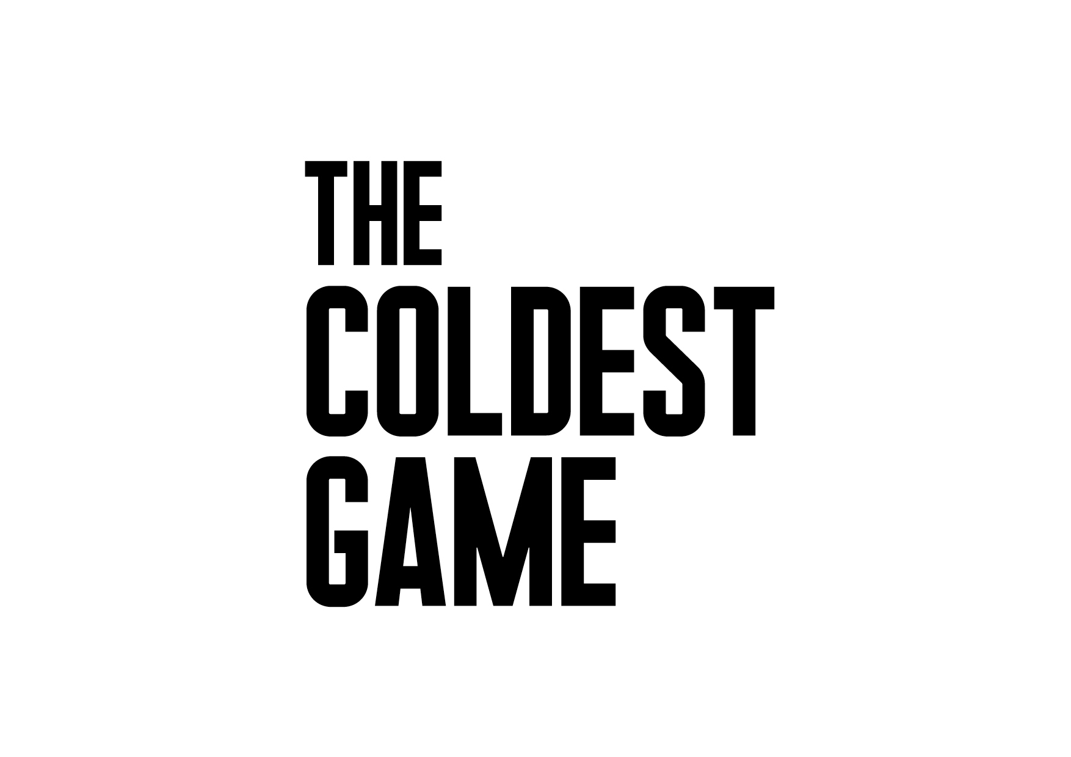
Warsaw, 22.03.2018

The Coldest Game – Watchout Studio's latest feature is halfway through shooting

On March 20th, in the unique interiors of the Palace of Culture and Science in Warsaw, a meeting between the actors, the filmmakers and the producers of the movie took place. The Coldest Game is the first movie by Polish producers made with international distribution in mind, and with English as the speaking language.

The meeting was attended by: director Łukasz Kośmicki, the filmmakers and the international cast. The impressions from the film set were shared by the actors: Bill Pullman, who plays the main protagonist (Joshua Mansky), Lotte Verbeek (Eleanor Stone), Robert Więckiewicz (Alfred Ślęga), Corey Johnson (Donald Novak) and James Bloor (Brian White). Set designer Allan Starski, cinematographer Pawel Edelman, as well as make-up artists Ewa Drobiec and Agnieszka Hodowana, all talked about the collaboration and their reasons for getting involved in the project.

- Given the excellent cast and the scale of the production, we are looking at an unprecedented project on the Polish film market. The unquestionable value of The Coldest Game is its gripping, compelling script written by Łukasz Kośmicki and Marcel Sawicki. Additionally, the story puts Warsaw at the heart of events of global significance. We hope that the viewers will be eagerly anticipating witnessing this tale. As for now, I would like to wholeheartedly thank all of you who were present at the conference, including the partners, co-producers and distributers. - Krzysztof Terej, a member of the board and a producer at Watchout Studio

Times change, yet the stakes remain the same

It's the 60's. The Soviet forces are sailing towards Cuba and Khruschev is threatening the USA with a nuclear attack. Tensions between the USA and the USSR are reaching a boiling point. Two grandmasters are preparing for a chess game: an American and a Russian. It's not going to be your usual game, for not only the grandmasters participate in the game, but also U.S. and Soviet counterintelligence agencies. The tournament takes place in Warsaw’s grand Congress Hall of the Palace of Culture and Science. Is it possible that once in Poland a game took place, that could have resulted in World War III?

„The Coldest Game” is the latest feature by Watchout Studio, responsible for such films as „Gods” and „The Art of Loving. The Story of Michalina Wisłocka”. For the first time ever, Polish producers are making a film with international distribution in mind, and with English as the speaking language.

The film's set, a unique scenery of the Palace of Culture and Science in Warsaw, is witnessing a meeting of i.a. Bill Pullman (Independence Day, The Sinner, Sleepless in Seattle), Lotte Verbeek (Nothing Personal, Outlander, The Borgias), Corey Johnson (Captain Phillips, The Bourne Ultimatum, The Mummy), Aleksey Serebryakov (Leviathan), Robert Więckiewicz (The Mighty Angel), and Allan Starski (Schindler’s List, Aftermath, Pan Tadeusz), with Łukasz Kośmicki as the director.

The film is shot from February to April 2018, and is planned for release in 2019. The partners of the film are the capital city of Warsaw and the Management Board of the Palace of Culture and Science. The film is co-financed by the Polish Film Institute. Hyde Park Entertainment Group is the international sales agent. The worldwide distribution is coordinated by K5 International, and the domestic by Next Film.

Starring: BILL PULLMAN, Lotte Verbeek, James Bloor, Corey Johnson, Aleksey Serebryakov, Robert Więckiewicz, Nicholas Farrell, Evgeniy Sidikhin

Make-UP: EWA DROBIEC, AGNIESZKA HODOWANA
COSTUMES: EWA GRONOWSKA
CASTING DIRECTORS: JEREMY ZIMMERMANN, NADIA LEBIK
SOUND DESIGN: JAROSŁAW BAJDOWSKI, MICHAŁ FOJCIK, BARTŁOMIEJ BOGACKI
MUSIC: ŁUKASZ TARGOSZ
EDITING: ROBERT GRYKA
PRODUCTION DESIGN: ALLAN STARSKI
CINEMATOGRAPHY: PAWEŁ EDELMAN
LINE PRODUCER: JUSTYNA PAWLAK
EXECUTIVE PRODUCER: OLIVER SIMON
SCREENPLAY: ŁUKASZ KOŚMICKI, MARCEL SAWICKI
PRODUCER: PIOTR WOŹNIAK-STARAK, KRZYSZTOF TEREJ, DANIEL BAUR
DIRECTOR: ŁUKASZ KOŚMICKI

POLISH DISTRIBUTION: NEXT FILM
INTERNATIONAL DISTRIBUTION: K5 INTERNATIONAL
INTERNATIONAL SALES AGENT: HYDE PARK INTERNATIONAL
COPRODUCTION: TVN INC., NEXT FILM, POLISH FILM INSTITUTE, ITI NEOVISION INC., BIG CITY OUTDOOR, THE STORY LAB, PORĘCZENIA KREDYTOWE, KOSAFILM, GALERIA OLŚNIENIA – GO JUSTYNA CHODKOWSKA

Contact info:
Zimna Gra | The Coldest Game
Biuro Prasowe | Press Office
zimna.gra@tbt.waw.pl

+ 48 604 062 236
+ 48 604 061 957
+ 48 604 062 172

