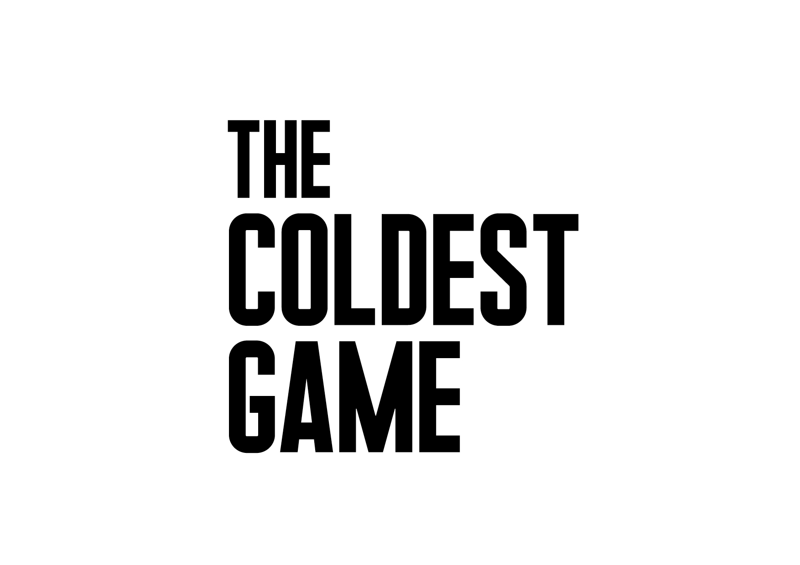
Warsaw, 28.02.2018

BILL PULLMAN WILL PLAY IN THE COLDEST GAME

Bill Pullman has joined the cast of the movie The Coldest Game. He will portray the film's protagonist – Joshua Mansky.

Bill Pullman will join the chess game. He is an American actor known for films such as Independence Day (in which he played the President of the United States), Lost Highway, Sleepless in Seattle, the Mel Brook’s hit Spaceballs. He’s worked with David Lynch, Lawrence Kasdan, Nora Ephron, Rob Reiner, among others. He’s played in over 90 films. He is the winner of the Locarno Film Festival Excellence Award for his unique contribution to cinema. He is the winner of many film awards including the CinemaCon Award, the Excellence in Acting Award at the Woodstock Film Festival and the Special Jury prize at the CineVegas film festival. He was recently nominated for a Critics Choice Award for his role in the critically acclaimed Golden Globe nominated television series The Sinner. Besides acting, he has a passion for building construction, which he studied in college. Pullman is active in his local communities. He has built a barn that is used as a community center, he works with the Cornerstone Theater in Los Angeles, Concerned Citizens Montana and supports the St. James Hospital and Alfred University near his hometown of Hornell, NY.

Pullman replaces William Hurt who had to pull out of the film having sustained an off-set injury just a few days into shooting.

Watchout Studio alongside producer Daniel Baur from K5 with the support of ICM Partners were able to re-cast the lead role with Bill Pullmann at short notice and to adjust the shooting schedule accordingly. Thanks for the whole team's commitment, after merely three-day break, the shooting has resumed in accordance with the original schedule.

I would like to wholeheartedly thank William Hurt for believing in the story we decided to tell. We wish him health and a speedy recovery. We are happy to announce that Bill Pullman has joined the cast. He is a versatile actor with an impressive resume, who has already brilliantly brought to life the character of Joshua Mansky – said Łukasz Kośmicki, The Coldest Game director.

THE COLDEST GAME:

A touching thriller and a spy tale depicting the story of a forgotten genius, a chess master Joshua Mansky (Bill Pullman) takes us behind the scenes of grand international politics and the timeless conflict between two superpowers. The eponymous game takes place in Warsaw, which in 1962 became the centre of events determining the fate of the world. Is it possible that once in Poland a game took place, that could have resulted in World War III?

The Coldest Game is the latest film by Watchout Studio, credited for such features as Gods and The Art of Loving. The Story of Michalina Wisłocka.

The film's set, a unique scenery of the Palace of Culture and Science in Warsaw, is witnessing a meeting of international cast and crew i.a. Bill Pullman (Independence Day, Lost Highway, Sleepless in Seattle, The Sinner), Lotte Verbeek (Nothing Personal, Outlander, The Borgias), Corey Johnson (Captain Phillips, The Bourne Ultimatum, The Mummy), Aleksey Serebryakov (Leviathan), Robert Więckiewicz (The Mighty Angel), and Allan Starski (Schindler’s List, Aftermath, Pan Tadeusz), Paweł Edelman (The Pianist, Stones For the Rampart, Walesa: Man of Hope), with Łukasz Kośmicki as the director.

It's the 60's. The American Dream is turning into a nightmare, the Soviet forces are sailing towards Cuba and Khruschev is threatening the USA with a nuclear attack. Tensions between the USA and the USSR are reaching boiling point. In Warsaw, two grandmasters are preparing for a chess game: an American and a Russian. It's not going to be your usual game. What will happen during this meeting? Who will turn out to be the real winner? One thing is certain: Joshua Mansky (Bill Pullman) will play a game where saving humanity from nuclear annihilation is what's at stake.

The eponymous game is set in the Palace of Culture and Science in Warsaw, which akin to the iconic Gotham City, will serve as a witness to the unfolding events of the eponymous game. The ever-present mystery of the place, its undiscovered rooms and secret passages which rarely can be seen in other films, will once again make the Palace a witness to its times. Through Allan Starski's set design and Paweł Edelman's lens, the Palace of Culture and Science will become one of the protagonists of this electrifying game...

Times change, but the game remains the same.

The film is shot from February to April 2018, and is planned for release in 2019. The partners of the film are the capital city of Warsaw and the Management Board of the Palace of Culture and Science. The film is co-financed by the Polish Film Institute. Hyde Park Entertainment Group is the international sales agent. The worldwide distribution is coordinated by K5 International, and the Polish distribution by Next Film.

STARRING: BILL PULLMAN, LOTTE VERBEEK, JAMES BLOOR, COREY JOHNSON, ALEKSEY SEREBRYAKOV, ROBERT WIĘCKIEWICZ, NICHOLAS FARRELL, EVGENIY SIDIKHIN

MAKE-UP: EWA DROBIEC, AGNIESZKA HODOWANA
COSTUMES: EWA GRONOWSKA
CASTING DIRECTOR: JEREMY ZIMMERMANN, NADIA LEBIK
SOUND DESIGN: JAROSŁAW BAJDOWSKI, MICHAŁ FOJCIK, BARTŁOMIEJ BOGACKI
MUSIC: ŁUKASZ TARGOSZ
EDITING: ROBERT GRYKA
PRODUCTION DESIGN: ALLAN STARSKI
CINEMATOGRAPHY: PAWEŁ EDELMAN
LINE PRODUCER: JUSTYNA PAWLAK
EXECUTIVE PRODUCER: OLIVER SIMON
SCREENPLAY: ŁUKASZ KOŚMICKI, MARCEL SAWICKI
PRODUCER: PIOTR WOŹNIAK-STARAK, KRZYSZTOF TEREJ, DANIEL BAUR
DIRECTOR: ŁUKASZ KOŚMICKI

POLISH DISTRIBUTION: NEXT FILM
Domestic Representation: K5 INTERNATIONAL
INTERNATIONAL SALES AGENT: HYDE PARK INTERNATIONAL
COPRODUCTION: TVN INC., NEXT FILM, POLISH FILM INSTITUTE, ITI NEOVISION INC., BIG CITY OUTDOOR, THE STORY LAB, PORęCZENIA KREDYTOWE, KOSAFILM, GALERIA OLśNIENIA – GO JUSTYNA CHODKOWSKA

Press office
The Coldest Game | Press Office
Małgorzata Maliszewska
zimna.gra@tbt.waw.pl
+ 48 604 062 236
+ 48 604 061 957
+ 48 604 062 172

