Warsaw, 14/02/2018

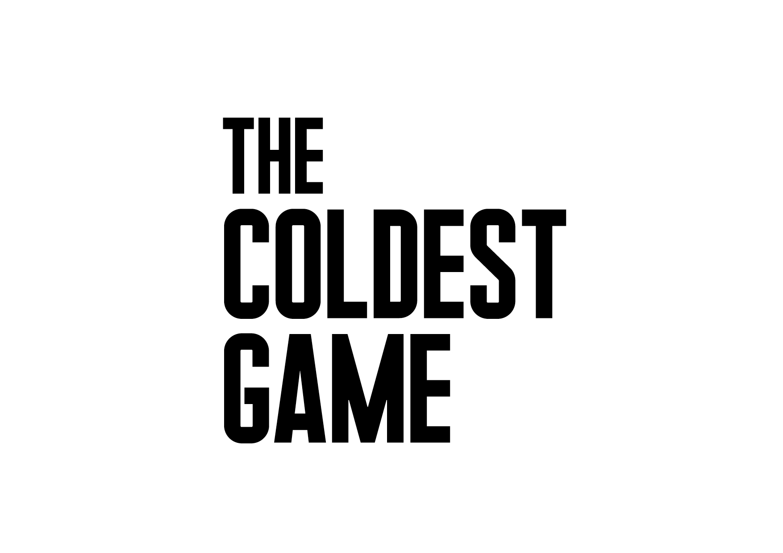
The Coldest Game: Times change – the stakes remain the same. Oscar-winning cast, Polish production. The latest film by Watchout Studio, credited for such features as "Gods" and "The Art of Loving. The Story of Michalina Wisłocka", is being shot.

A touching thriller and a spy tale depicting the story of a forgotten genius, a chess master Joshua Manski (William Hurt) takes us behind the scenes of grand international politics and the timeless conflict between two superpowers. The eponymous game takes place in Warsaw, which in 1962 became the centre of events determining the fate of the world. Is it possible that once in Poland a game took place, that could have resulted in World War III?

The film will be shot extensively in the unique setting of the Palace of Culture and Science in Warsaw which features as another character in the film. The production brings together a truly impressive collection of world-famous and award-winning talent both in front of and behind the camera. Actors and crew include Oscar-winners and nominees, and winners of the highest accolades in Poland. Among the highly-acclaimed actors are Oscar Winner William Hurt (for Kiss of the Spider Woman, A History of Violence, Mr. Brooks), Locarno Silver Leopard Winner Lotte Verbeek (Nothing Personal, Outlander, The Borgias), Aleksey Serebryakov (multi award-winner and nominee with Leviathan), winner of multiple Polish Film Awards Robert Więckiewicz (The Mighty Angel) and Corey Johnson (Captain Phillips, The Bourne Ultimatum, The Mummy). Award-winning crew members include Oscar-winning production designer Allan Starski (Schindler’s List, Aftermath, Pan Tadeusz), and Oscar-nominated cinematographer Paweł Edelman (The Pianist, Stones For the Rampart, Walesa. Man of Hope). Director Łukasz Kośmicki is himself an award-winning cinematographer and writer.

It's the 60's. The American Dream is turning into a nightmare – the Soviet forces are sailing towards Cuba and Khrushchev is threatening the USA with a nuclear attack. The tension between the USA and the USSR is reaching boiling point. In Warsaw, two players are preparing for a chess game: an American and a Russian. It's not going to be your usual game. What will happen during this meeting? Who will turn out to be the real winner? One thing is certain: Joshua Mansky (William Hurt) is going to play a game where saving humanity from nuclear annihilation is what's at stake.

The setting: the Palace of Culture and Science, akin to the iconic Gotham City, will serve as a witness to the unfolding events, and as the location for the eponymous game. The ever-present mystery of the place, its undiscovered rooms and secret passages which rarely can be seen in other films, will once again make the Palace a witness to its times. Through Allan Starski's scenery and Paweł Edelman's lens, the Palace of Culture and Science will become one of the protagonists of this electrifying game...

Times change, yet the power play between East and West continues

Producers Piotr Woźniak-Starak and Krzysztof Terej, who have successfully told real-life tales before, this time leave it to the viewer to answer the question: “Did this story actually happen?”.

„The chess game, The Cuban Missile Crisis, President Kennedy and Secretary Khrushchev all existed. The Palace of Culture and Science still towers over the centre of Warsaw. By mixing facts and fiction, we hope that the emotions as well as the intrigue between the two chess masters and intelligence agents from the two superpowers will deliver unforgettable thrills to the audiences.” – Łukasz Kośmicki, the director of The Coldest Game

The Coldest Game is going to be shot from February till April 2018, and the premiere is due to take place in spring 2019. City of Warsaw and the board of The Palace of Culture and Science Ltd. are partners of the film. The Polish Film Institute is co-financing. Hyde Park Entertainment Group is the international sales agent for the film and K5 International is responsible for worldwide distribution with Next Film being responsible for the distribution in Poland.

Starring: William Hurt, Lotte Verbeek, James Bloor, Corey Johnson, aleksey Serebryakov, Robert Więckiewicz, Nicholas Farrell, Evgeniy SIdikhin

MAKE-UP: EWA DROBIEC, AGNIESZKA HODOWANA
COSTUME DESIGNER: EWA GRONOWSKA
CASTING DIRECTOR: NADIA LEBIK, JEREMY ZIMMERMANN
SOUND: JAROSŁAW BAJDOWSKI, MICHAŁ FOJCIK, BARTŁOMIEJ BOGACKI
MUSIC BY: ŁUKASZ TARGOSZ
EDITOR: ROBERT GRYKA
PRODUCTION DESIGNER: ALLAN STARSKI
DIRECTOR OF PHOTOGRAPHY: PAWEŁ EDELMAN
PRODUCTION MANAGER: MAGDALENA MALISZ
LINE PRODUCER: JUSTYNA PAWLAK
EXECUTIVE PRODUCER: OLIVER SIMON
SCREENPLAY BY: ŁUKASZ KOŚMICKI, MARCEL SAWICKI
PRODUCED BY: PIOTR WOŹNIAK-STARAK, KRZYSZTOF TEREJ, DANIEL BAUR
DIRECTED BY: ŁUKASZ KOŚMICKI

Distribution in Poland: Next Film
International Distribution: K5 International
International Sales Agent: Hyde Park Entertainment Group

Co-producers: TVN, Next Film, ITI Neovision S.A, Big City Outdoor, The Story Lab, Poręczenia Kredytowe, Kosafilm, Galeria Olśnienia GO - Justyna Chodkowska.

Press office
The Coldest Game | Press Office

Malgorzata Maliszewska
zimna.gra@tbt.waw.pl

+ 48 604 062 236
+ 48 604 061 957
+ 48 604 062 172

