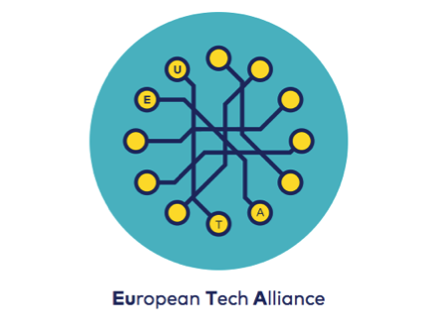

EUROPE’S TECHNOLOGY LEADERS FORM NEW ALLIANCE

- The European Tech Alliance will promote the scaling up of fast-growing European tech companies
- Members will share their experience of building their businesses in Europe with policymakers
- The European Tech Alliance aims to close the gap in terms of European representation for scale ups and contribute to the Commission’s Digital Single Market strategy
- The Alliance will be launched by the Commission’s Vice-President Andrus Ansip and hosted by Catherine Stihler MEP

STRASBOURG, France, October 27, 2015 – A group of high-tech companies announced the formation of the European Tech Alliance on Tuesday, designed as a resource for European governments and EU institutions to help the industry scale up and create jobs in Europe.

“We have formed an alliance to share our collective experience with policymakers and challenge mindsets about Europe, technology, and the Internet,” said Niklas Zennström, president of the group and the co-founder of Skype. He is now founder and CEO at Atomico.

“There are so many European tech company success stories. We think we will be able to help European leaders understand that Europe is good at tech and show how policymakers can clear the way for the tech industry to grow further.”

European Commission Vice-President Andrus Ansip, who is leading the Digital Single Market strategy, endorsed the creation of the Alliance.

“I am delighted that the Alliance has come together to open a new line of communication with policymakers in the EU. Their experience of building businesses from the ground up in Europe will be an important contribution as we create a Digital Single Market,” he said.

Zennström said that the Alliance will look to further the goals of the Commission’s proposed digital strategy.

“The next 12 to 18 months will be particularly critical because the European Commission is writing rules to carry out its Digital Single Market strategy, aimed at clearing the way for all tech players – from the EU and beyond - to invest, grow, and prosper in Europe,” he said.

The Alliance will look to work with European Union institutions and Member States and commit to share their experience of building tech companies in Europe, so that any legislation or regulation that the EU looks to introduce nurtures the tech sector and enables it to compete on a global level.

It includes companies built in Europe that have recently found success in the tech sector, and who are looking to scale up and are committed to being part of growing the digital economy.

Scaling up existing businesses in the region is vital for Europe as it can help generate jobs, growth, and consumer value.

Contacts:
Linda Griffin, King +44 77 32 65 73 49 linda.griffin@king.com
Fabrizio Porrino, FacilityLive +32 487 53 69 12 fabrizio.porrino@facilitylive.com
ANNEX 1 Alliance members and contact details
 | Allegro Group operates the leading Central and East European online marketplaces. | Chris Sherwood  chris.sherwood@allegrogroup.com
 | Appear Here is the leading online marketplace for short-term retail space. | Becky Jones  becky@appearhere.co.uk
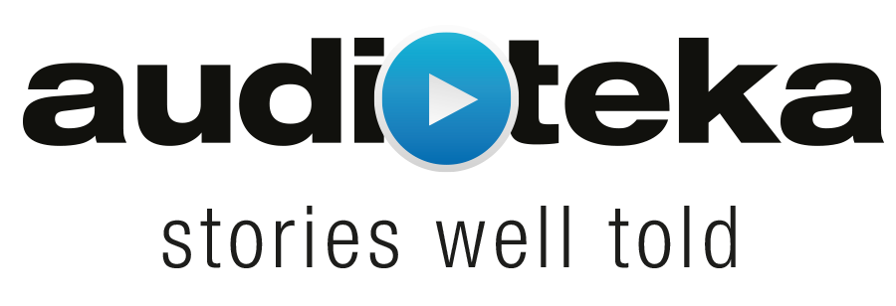 | Audioteka is a mobile-first audiobook platform providing access to a wide variety of books, literature, and articles in an easily accessible audio format available in 9 languages in over 20 countries. | Marcin Beme  marcin.beme@audioteka.com
 | Avast Software is the maker of the most trusted mobile and PC security in the world and protects 230 million people and businesses with its security solutions. | Alan Rassaby  rassaby@avast.com  Veronika Pokorná  pokorna@avast.com
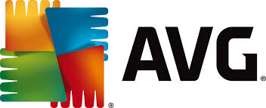 | AVG is the online security company for devices, data and people with more than 200 million monthly users across the globe. | Harvey Anderson  harvey.anderson@avg.com  Deanna Contreras  deanna.contreras@avg.com
 | Barnebys is the number one search service for arts, antiques and rarities. | Gustaf Grapengiesser  gustaf@barnebys.com
 | BlaBlaCar is the world’s leading long distance ridesharing platform that connects drivers and passengers going the same way to share the cost of the journey. | Diane Prébay  diane.prebay@blablacar.com
 | Brand24 is a social listening app that gives you instant access to mentions about your brand across the web. | Mike Sadowski  mike@brand24.net
 | Dreamstime is the world's largest stock photography community. | Carmen Maftei  carmen@dreamstime.com
 | FacilityLive is the Disruptive European Search Technology Made-in-Italy. | Fabrizio Porrino  fabrizio.porrino@facilitylive.com
 | Just Spices is a leading German based e-commerce spice company with the vision to emotionalize the spice market. | Florian Falk  florian@justspices.de
 | King is a leading interactive entertainment company for the mobile world. | Linda Griffin  linda.griffin@king.com
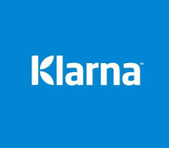 | Klarna is a global online payments provider with the goal to become the world’s favourite way to buy. | Jesper Wigardt  jesper.wigardt@klarna.com
 | MADE.COM is an online design brand based in Soho, London. By connecting customers directly with manufacturers to create original products, MADE is on a mission to make great design accessible to everyone. | Amy Grimshaw  amy.grimshaw@made.com
 | Momondo Group is a global online travel search and inspiration network, operating the Cheapflights, Momondo and Skygate brands in more than 30 countries. | Phil Bloomfield  phil.bloomfield@cheapflights.co.uk
 | Prowly is a CRM tool for Public Relations professionals in the digital age. | Joanna Drabent  joanna@prowly.com
 | Rovio Entertainment Ltd, the creator of Angry Birds™, is a global industry-changing entertainment media company headquartered in Finland that creatively combines digital with physical, breaking the boundaries of traditional content delivery. The Angry Birds Movie is slated for May 2016. | Kaisu Karvala  kaisu.karvala@rovio.com
 | Seznam.cz is a search engine and digital services provider. | Michal Feix  michal.feix@firma.seznam.cz  Libor Manda  libor.manda@firma.seznam.cz
 | Spotahome is an online booking site for mid to long-term accommodation in Spain, Italy, Belgium, Ireland and France. | Alejandro Artacho  artacho@spotahome.com  Pilar Zaforteza  pilar@spotahome.com
 | Spotify is the global leading music streaming service. | Marine Elgrichi  marine@spotify.com  Alison Bonny  alison@spotify.com
 | Supercell is a mobile game developer based in Helsinki, Finland, with offices in San Francisco, Tokyo, Seoul and Beijing. | Linda Åström  linda.astrom@supercell.com
 | Swiftkey is a free app for Android, iPhone and iPad that makes it easier, faster and more fun to type. It adapts to you so you spend less time correcting your typos and more time expressing what you really mean. | Sarah Rowley  sarah.rowley@swiftkey.com
 | The Pole Society is the first platform in the world to offer a one-stop shop for your multi-channel advertising needs. | Bogdan Savonea  bogdan.savonea@thepolesociety.com
 | Transenter is an innovative Language Service Provider using technology to streamline the process and save costs. | Pawel Walentynowicz  pw@transenter.com
 | ZED is the leading company in advanced mobile services with over 18 years’ experience. | Jorge Calderon  jcalderon@zed.com  Marta Izquierdo  marta.izquierdo@u-tad.com

